JM.Lauritsen

Specification of graphs in EpiAnalysis.

The basic formulation of graphs are those described in The Elements of Graphing Data, Cleveland (1994) in which he advocates and demonstrates a lean graph layout. The information should stand out as clearly as possible, and superfluous elements and distracting decoration should be avoided. Implementations of the principles has also been discussed by Svend Juul.

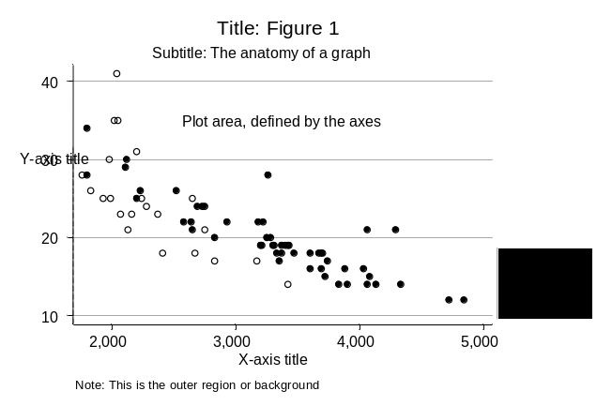Another of Cleveland's major points is the importance of the aspect ratio or y/x ratio to the visual interpretation of a graph.

By the aspect ratio is meant the relative size of y and x axis. Therefore to make proper graphs the following must be in control of the user:

- Length of x and y axis
- Size of graphing area (rectangle bordered by the x and y axis)
- Total size of graph including labels, texts, tick marks etc.

EpiData Analysis will not be a comprehensive graphing program, but will have major graph types used in research, public health reporting and quality control implemented with several aspects in control of the user.

Users wishing more control of graphs can use other programs, e.g. Stata version 8 for which the same graph types can be used, but with more options available.

Untill fully implemented actual graphs shown in this document have been produced with Stata (www.stata.com) or supplied by Gruk, Norway (Statistical Process Control Graphs).

Main Graph types:
Basic types | Variables: One  Two | Histogram, Bar, Line, Box  Scatter
Special Graphs | Public Health  Statistical Process Control  Survival  Distribution  Other | Epidemic Curve  Run, Ichart(=XMR), Pchart, XBar  Kaplan Meier Plot  A variant of Quantile/Probit  Pie, Venn Diagram
Notes: Types in bold expected in first release. In addition to graph type, various aspects of the graph can be controlled by general og special options.
Overview of graph commands and options

Main Graph types:
Command | variables | options |  | Implement*
Histogram | X [group var] |  | Missing X values are added | 1
Bar Hbar | X [group var] | /Stack  /Percent  /Count | Only X values in data are shown | 1
Box | one
Scatter | X Y1 [Y2...Yn] | /Line(y1,y2..)  /Marker(y1,y2  /Show(y1,y2... | Symbols plotted for non-missing x,y  /Line 0:no 1:line 2:.. 3:-- 4:lcfi 5:ucfi  lcfi and ucfi indicates connection vertically to series Y1.  /Marker: (added later)  /Show: show marker of that variable | 1
Line | X Y1 Y2...Yn |  | Scatter plot with lines and no markers
EpiCurve | time outcome [type] |  | Shows a box at values of time for each observation where “outcome=1”. Color Scheme or grade by [type]
KMPlot |  |  |  | 2
Quantile/Probit |  |  |  | 2
Venn |  |  |  | 2
Pie |  |  |  | 1
SPC graphs: |  | (See SPC options) | “Time” for X-axis may be: Date, sequence, Recnumber. (String might wait for next release)
Run | Time Count |  | No control limits are shown here
Ichart | Time Measurement |  | Overall moving range control limits are used.
Pchart | Time Count Total |  | Proportion of each count of total
Cchart | Time Count Num |  | Num must be a constant indicating the volume per time unit.  Count/Numerator is shown
Uchart | Time Count Total |  | Count/Total is shown
XBar | Time measurement | /Sigma /Range  /R2 | Datafile contains > 1 value pr time unit. Data aggregated to one value pr time. Two charts are shown:  Top: I-Chart of mean values  Bottom: Sigma, Range or min+max for for each value of X.  XBar without options only shows the “I-Chart” of the aggregated values
* Right most column indicates development stage. 1: first release 2: later release. blank: undecided. Not all options will be added in release 1.

Options are shown on next page.

Option for graphs | values/parameters | Default values can be omitted | Implement*
Set
set graphsave | on/off | Save a graph automatically after showing |  | 1
set graphtype | png/wmf/gif | Type of graph file saved
set graphshow | on/off | Show graph in output window |  | 1
set graphedit | on/off | Show graph specification editor
Command line
/BY | (variable,type) | Values of plotted var stratified by variable. (Common x and y axis) Type: 0: One graph 1: Subgraphs 2: Subgraph plus total
/Save | (file name) | Default “graphttmmss” e.g. graph104722.png
/TItle | (text) | Use these texts for the graph
/SUbtitle | (text)
/FOot | (text)
/XText /YText | (text) | axis legend for Y / X axis
/TRef | (x,text,box:0/1) | Add text at point x top aligned with optional box. From center of text a reference arrow will be pointing down, length 1 cm.
/Text | (x,y,text,box) | Add text at point x,y aligned with optional box.
/XLine | (x,y1,y2) | Vertical line at value x værdi (optional from y1 to y2)
/YLine | (y,x1,x2) | Horisontal linie at value y (optional from x1 to x2)
/BW | no parameter | Show all graph elements in black
/Xaxis /Yaxis | (length,position,log, invers,visible) | length: lenght in pixels of axis. inversion of values: 0:No 1:yes.  log scale: 0: No 10: log¹⁰ ln: base 2.71828 e: base 2.71828  position: gap in pixels , e.g. 10 or –10. visible: 1 yes 0 no.
/XScale /YScale | (min,max) | Set scale of X/Y axis to values
/XAngle /YAngle | (value) | Angle for axis labels
/XTICK /YTICK | (outer,inner,count, length) | outer/inner: length of tick marks  count length: Number and length of minor marks
/table | (where) | add data table 1: above 0: below.
/legend | (show,x,y,box,shade) | Show legend, position, type of box, shade/3d
/grid | (box,xgrid, ygrid) | box is a bounding box at end of axis. xgrid and ygrid horiz./vert.
/Xlabel | Variable | Text to be shown along x axis instead of Xvalue |  | 2
Options for SPC graphs:
/EXclude | (variabel) | Observations with value 1 in variable are excluded from calculations.
/Break | (variable=value,text,box,line,show) | Split computation at x.  Text w optional box shown at x.  Line: adds vertical line at x  Show: show control limits: 1: yes 0: no
/TEST | (t1,t2,t3, show) | Default is test for all. Each of t1-t3: 1: yes 0:no  t1: values exceeding control limits  t2: 7 consecutive values on same side of center line  (in run diagram based on number table)  t3: Trend: 6 punkter med stigende/aftagende værdi (7 dersom 20+ observasjoner)  show: Add * at X values if any applied test is positive. (or change databpoint attribute i.e. from solid fill to outline)
/CBand | (line,colour) | Add dotted line to indicate deviance from mean  line: 0: no 1: yes (adds at 1,2 and 3 Sd’s)  colour: 0: No, 1: Yes (add coloured band)
/neglcl | no options | Show negative lower control limit
* Right most column indicates development stage. 1: first release 2: later release. blank: undecided

Examples of Graphs and comments
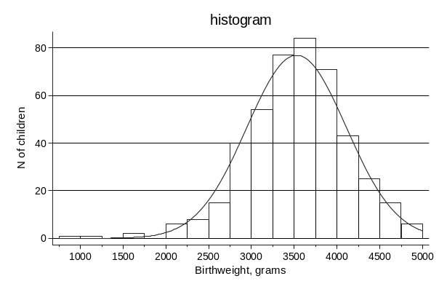
histogram

A histogram depicts the distribution of a continuous variable. The y-axis may reflect a count (frequency), a density or a percentage; the corresponding normal curve may be overlaid.

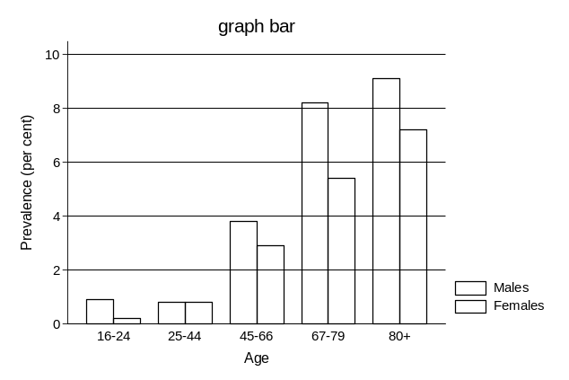
Bar Hbar

In bar graphs the x-axis is categorical, the y-axis continuous. Y axis can indicate counts (option COUNTS), fractions (Option fraction) or percents (Option percent). With subgroups as here the percentages or fractions are fractions of the complete sample (Here male+female all ages are 100%)

Hbar is the same but horisontal bars instead.

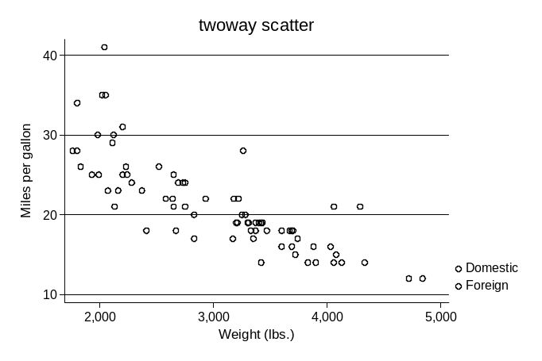

Scatter

Scatter graphs have continuous x- and y-axes; A graph with one plot has no legend; this one with a grouping variable. The default legend texts are taken from value labels of the grouping variable. Optional a linear regression line (option regress) and possibly later a spline fitted curve

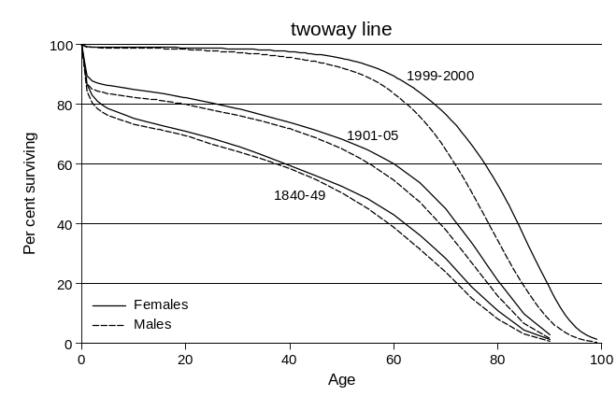
Scatter with points connected

A line plot is a variation of scatterplot without markers, but with connecting lines.

This graph includes six lines based plots, required by one plot-specification with six y- and one x- variable.

Data are sorted with the x-axis variable. Supplementary texts are added with options.
20
40
60
80
100
Mean score
PF
RP
BP
GH
VT
SF
RE
MH
SF-36 subscale
Observed
Expected
95% CI
Scatter with lines connected
Scatter
special lines

As options linetypes, connections and markers can be specified in options. E.g. for for showing confidence intervals.

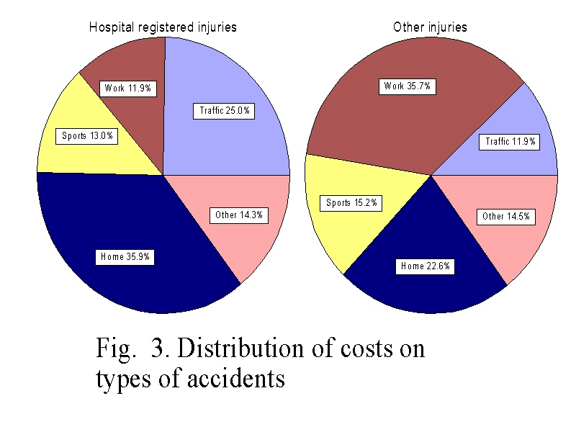Pie Charts

Althoug disliked by many – some find these intuitive and pie charts will therefore be possible.

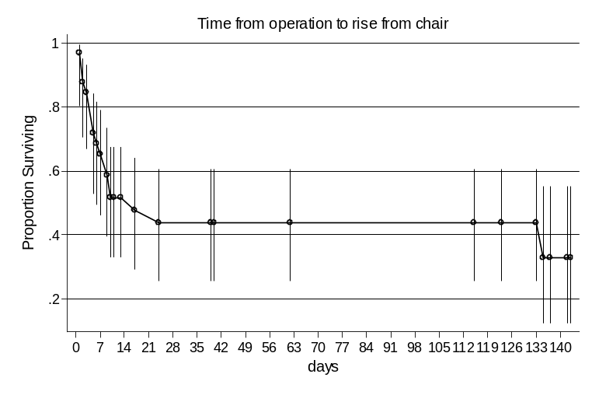
Kaplan Meier plots

A special case of the line plot is a Kaplan Meier Plot of the survival function estimates from a life table analysis with confidence intervals.

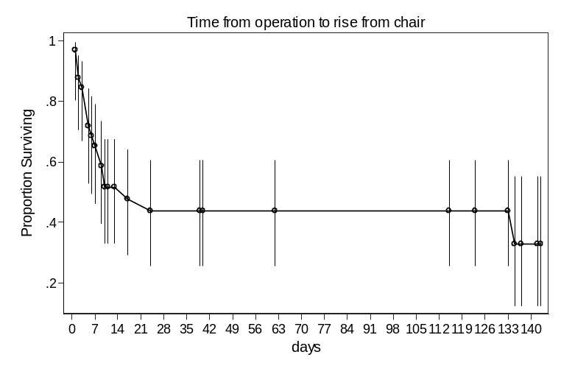

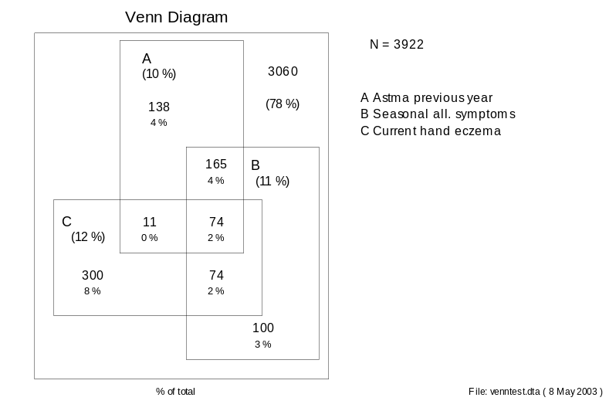

Venn Diagrams

An efficient way of showing sub group combinations of variables.

Statistical Process Charts
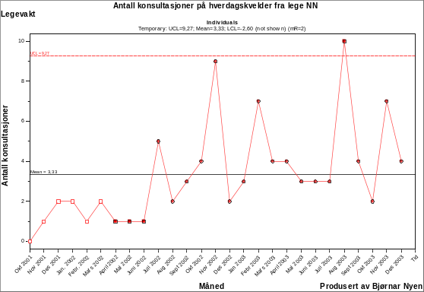
These have been developed in collaboration with Gruk, Norway.

Basic I-Chart

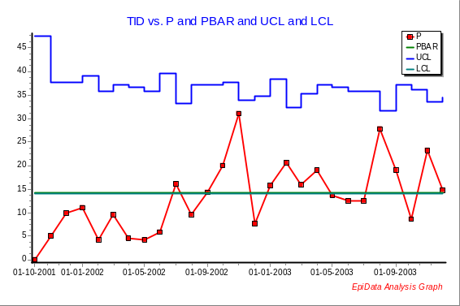

P-Chart

The P-Chart shows proportion of counts divided by total number of observations

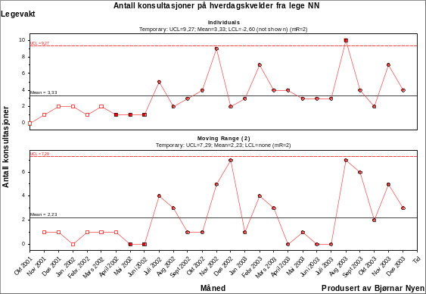
XBar chart
This is a double chart showing subgroup averages as datapoints in the top diagram (with Control limits), and subgroup ranges (or dispersion indicated by sigma) with respective control limits in the lower subdiagram.

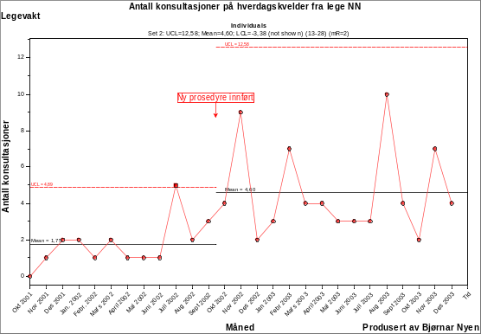
Special options

As part of the SPC analysis options as well time splits can be applied, texts added and angling of the labels for x – axis.

Cleveland, W. S. 1994. The Elements of Graphing Data. Summit, NJ: Hobart Press.
The implementation will also follow recommendations by Svend Juul in the note on introduction to Stata and in an article in Stata Journal on “lean graphic schemes”? SJ 3(3):295--301. Parts of this text based on an early version of that article with permission from Svend Juul.
Figures and text copied, translated anbd adapted from: Nyen B, Høgli V. Forbedringsarbeid og Statistisk Prosesskontroll (SPC) - kompendium. Stiftelsen Gruk, Skien Norway, 2004. (preliminary) post@gruk.no.

